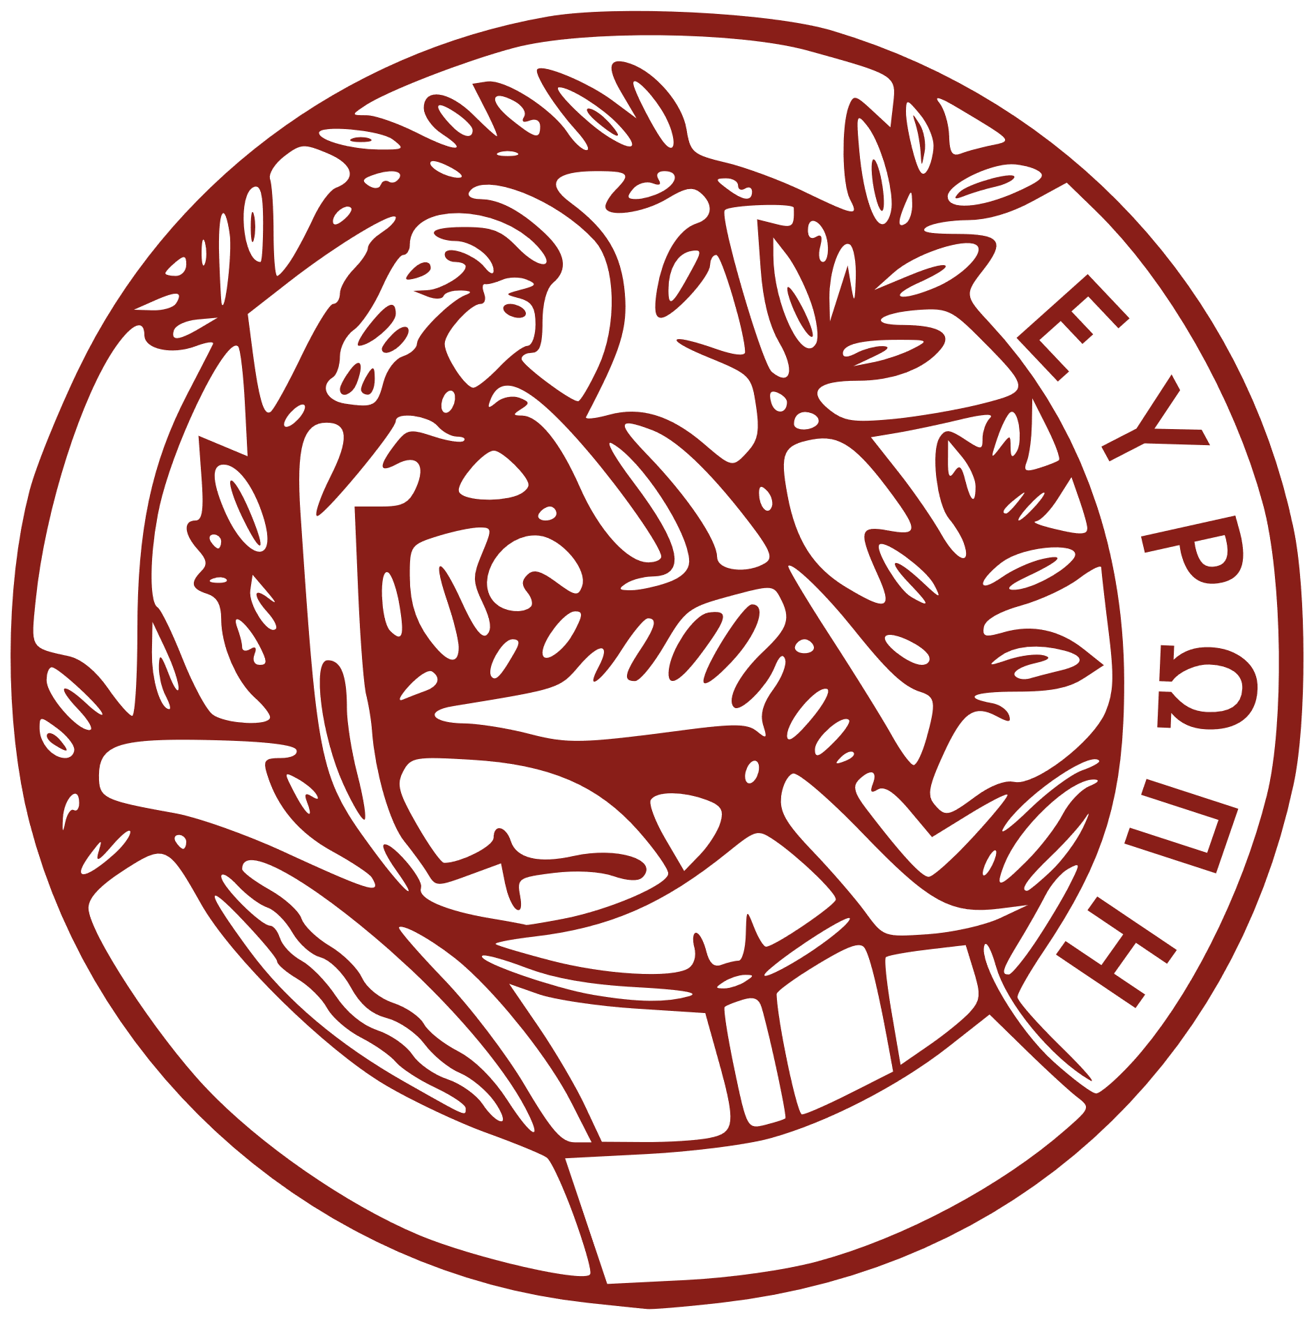 | School of Sciences and Engineering  MSc Program in “Materials Science and Technology”
University of Crete

Student Course Declaration Form
__________ semester of the academic year 20__ – 20__

Full name: ________________________
Registration number: ________________________

COURSES:
COURSE CODE | TITLE | DEPARTMENT

Note: From the Academic year 2022-2023 all courses of the MSc program in “Materials Science and Technology” curriculum will be conducted in English. Courses that are conducted in Greek will be referred only at the MSc Degree supplement, and their ECTS units will not be counted for the 120 ECTS to complete the curriculum.

STUDENT  (SIGNATURE) | SUPERVISING PROFESSOR / DIRECTOR OF THE POSTGRADUATE PROGRAMME (SIGNATURE)
___________________________ | ___________________________

